**Lab Exercise 3 - Selenium IDE - Creating Tests**

**Creating a Test in Selenium IDE**

The steps to create a test in Selenium IDE are listed below −

**Step 1** − Click on the Selenium IDE extension visible on the browser after its installation.

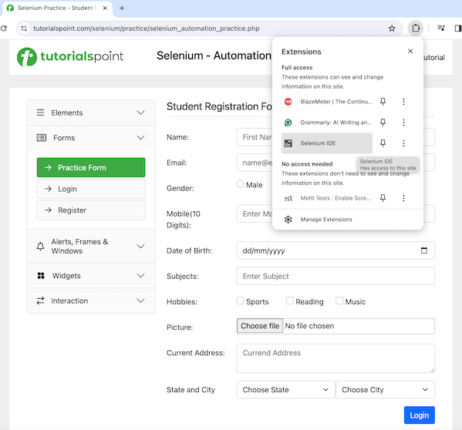

**Step 2** − Selenium IDE should be launched along with it, a welcome message should be displayed with the version of the tool. In the below image, the version installed is 3.17.2.

Along with this, it gives us the option to select what we would like to do with the tool, like Record a new test in a new project, Open an existing project, Create a new project, and Close Selenium IDE.

Also, a link with the text - **the Selenium IDE project page** is provided, which on clicking would land us to the Selenium Integrated Development Environment documentation page.

<https://www.selenium.dev/selenium-ide/>



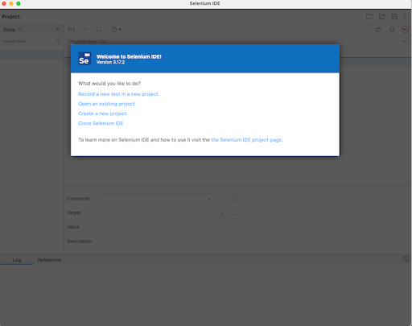



**Step 3** − We would click on the option **Record a new test in a new project**. After which we would need to enter the **PROJECT NAME**, say **SeleniumIDE1**. Finally, we would click OK.

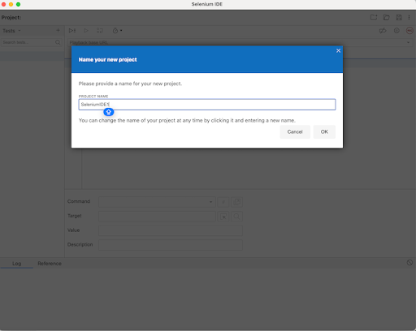



**Step 4** − Before starting with creating a test in Selenium IDE, we would need to specify the application Base URL, where we would record and create the test. In the below image, we had entered the Base URL: <https://www.tutorialspoint.com/selenium/practice/selenium_automation_practice.php> Finally, we would need to click on the **Start Recording**.

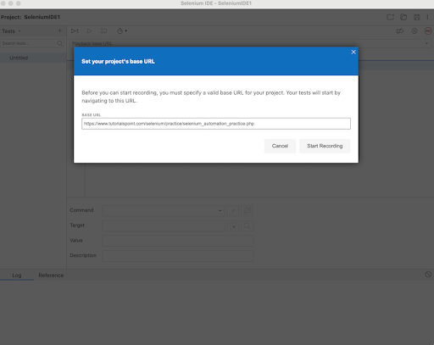

**Step 5** − The corresponding application whose Base URL had been provided in Step4 should be opened with Selenium IDE logo and Selenium IDE recording message in red. Also, a red icon(highlighted in the below image) should be visible at the top of the Selenium IDE, denoting recording is in progress in the application.

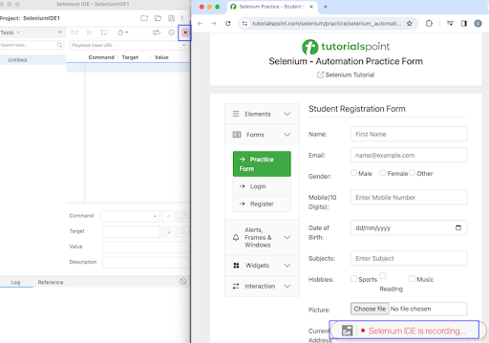

**Step 6** − We would perform some steps on the application and corresponding steps would be recorded in the Selenium IDE as well.

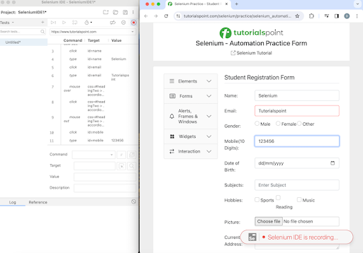

**Step 7** − Once all the tests have been performed, we would stop the recording by clicking on the red icon as mentioned above in Step5. After which, we would need to enter a name for the test. In the below image, we had entered the **TEST NAME** as TestCase1. Finally, we would click on the OK.



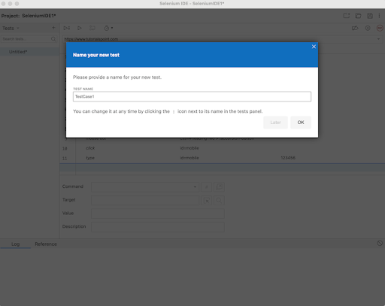

**Step 8** − All the steps that we had performed on the application would be recorded in the Selenium IDE under the Command, Target, and Value fields. Also, the test case name - TestCase1, would be visible to the left pane along with a **REC** button to the top right.

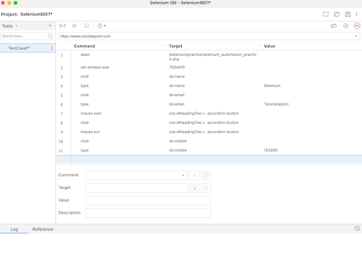



**Step 9** − Once the test would be created, we would be able to get the details on that step, by clicking on it. Once done, it would be visible under the Command, Target, and Value fields at the bottom. In the below example, we had clicked on the fourth step, where the values of **Command, Target**, and **Value** fields are **type, id=name**, and **Selenium** respectively. In this step, we had basically entered the text Selenium in an input box which was identified with the id locator having the value as name.

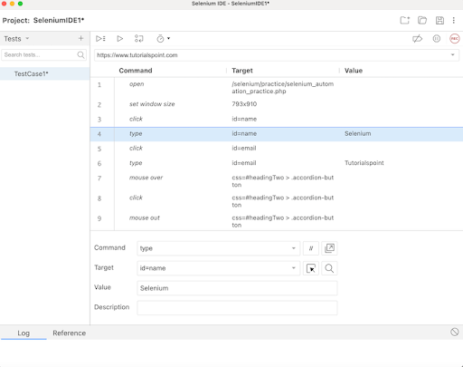

**Step 10** − If we would click on the dropdown in the Target field, we would observe that Selenium IDE while recording was successful in capturing all the other locator values for an element. In the below example, we had clicked on the fourth step, where the **values of Command, Target**, and **Value** fields were **type, id=name**, and **Selenium** respectively. In this step, other locator values like the name, css, and so on for that element were visible within the Target dropdown.

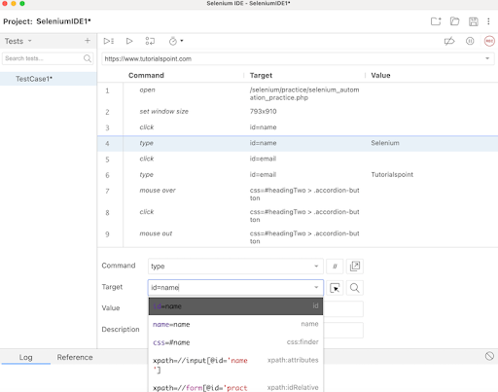

**Step 11** − Once we would click on any step of the test we had created, we would get the details of the command and the action taken place, by navigating to the **Reference** tab at the below.

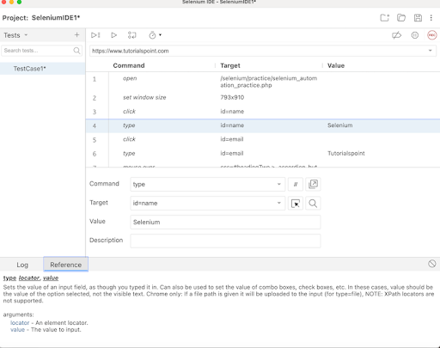

**Step 12** − We can right click on any step and get the option to manually insert a new command(for addition of a new step), cut, copy, clear, Toggle breakpoint(used for debugging) on a step, and so on.

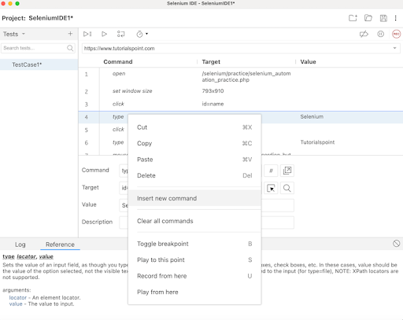

**Step 13** − To run the test created, we would click on the **Run current test** button at the top as shown in the below image.

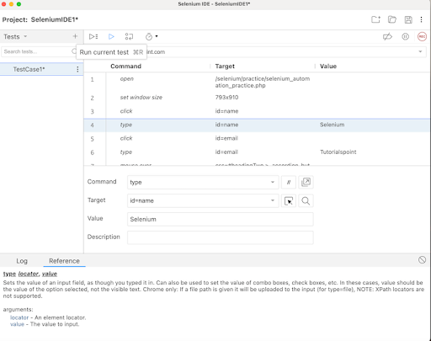

In case, there are multiple tests, we would need to click on the **Run all tests** button as shown in the below image.

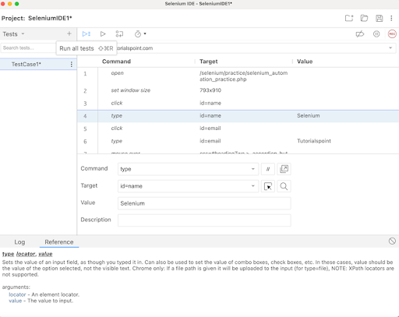

In case, there are breakpoints added to steps, we would need to click on the **Step over current command** button as shown in the below image where the steps 2, and 4 have breakoints.

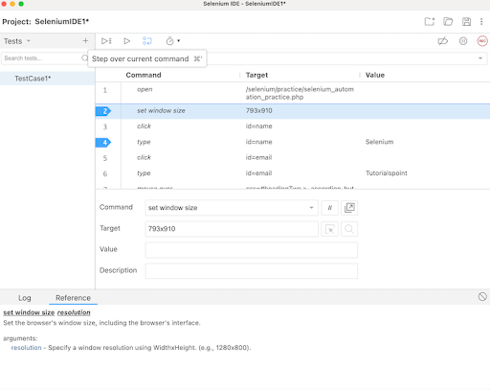

**Step 14** − We can control the speed of test execution using the **Test execution speed** button as shown in the below image .

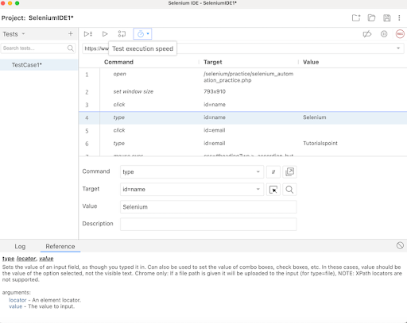

By default, the speed is set to Fast in Selenium IDE.

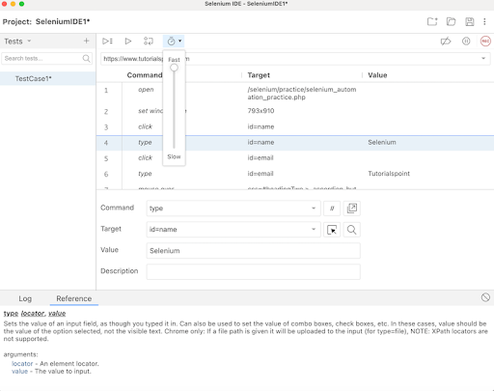

**Step 15** − Selenium IDE gives the option to Create, Open and Save a project using the icons at the top right upper corner as highlighted on the below image.

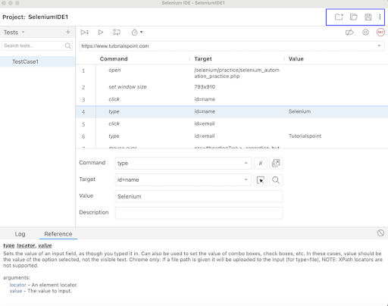

We would Save our project and continue. Once saved, we would be required to give a Name and location where our project would be saved.

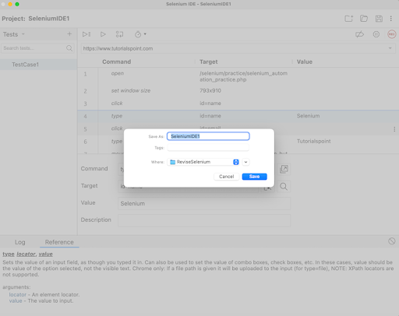

**Step 16** − We would run the test - TestCase1 using the **Run current test button**.

**Step 17** − Once the execution would be completed, we would get the message of the result. In case, the test passed, we would get the message - <TEST NAME> completed successfully under the Log tab at the bottom of the Selenium IDE. Here, our test name was TestCase1, hence received the message - **TestCase1 completed successfully**.

Apart from that, the all the test steps, along with the test case name turned green, reflecting a PASS for all the steps. All the steps which reflected under the Log tab, showed an OK in green.

Thus, in Selenium IDE, we would get the information about the test results both at the test step level and only if all the steps would be executed successfully, we would get a PASS at the test case level as well.

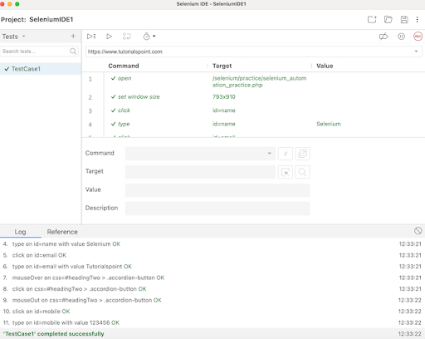

Thus, in this tutorial, we had discussed about how to create a test using the Selenium IDE.